## What Is Discrete Distribution?

A discrete distribution is a statistical distribution that shows the probabilities of outcomes with finite values. Statistical distributions can be either discrete or continuous. A continuous distribution is built from outcomes that potentially have infinite measurable values.

What is a Binomial Distribution? Real Life Examples

Many instances of binomial distributions can be found in real life. For example, if a new drug is introduced to cure a disease, it either cures the disease (it’s successful) or it doesn’t cure the disease (it’s a failure). If you purchase a lottery ticket, you’re either going to win money, or you aren’t. Basically, anything you can think of that can only be a success or a failure can be represented by a binomial distribution.

The Binomial Distribution Formula

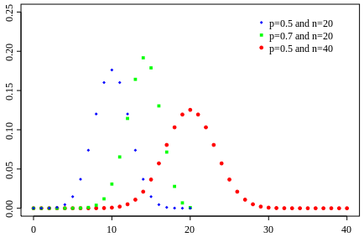

The binomial distribution formula is:

**b(x; n, P) = nCx * Px * (1 – P)n – x**

Where:  
b = binomial probability  
x = total number of “successes” (pass or fail, heads or tails etc.)  
P = probability of a success on an individual trial  
n = number of trials

**Note:** The binomial distribution formula can also be written in a slightly different way, because nCx = n!/x!(n-x)! (this binomial distribution formula uses factorials [(What is a factorial?](https://www.statisticshowto.datasciencecentral.com/factorial-distribution/#definition)). “q” in this formula is just the probability of failure (subtract your probability of success from 1).  
[binomialprobabilityformula](https://www.statisticshowto.datasciencecentral.com/wp-content/uploads/2009/09/binomialprobabilityformula1.bmp)

## What is a Geometric Distribution?

The geometric distribution represents the number of failures before you get a success in a series of [Bernoulli trials](https://www.statisticshowto.datasciencecentral.com/bernoulli-distribution/#trial). This [discrete probability distribution](https://www.statisticshowto.datasciencecentral.com/discrete-probability-distribution/) is represented by the [probability density function](https://www.statisticshowto.datasciencecentral.com/probability-density-function/):

**f(x) = (1 − p)x − 1p**

For example, you ask people outside a polling station who they voted for until you find someone that voted for the independent candidate in a local election. The geometric distribution would represent the number of people who you had to poll before you found someone who voted independent. You would need to get a certain number of failures before you got your first success.

## Example

**Sample question**: If your probability of success is 0.2, what is the probability you meet an independent voter on your third try?  
Inserting 0.2 as p and with X = 3, the probability density function becomes:  
f(x) = (1 − p)x − 1*p  
P(X=3) = (1 − 0.2)3 − 1(0.2)  
P(X=3) = (0.8)2*0.2 = 0.128.  
[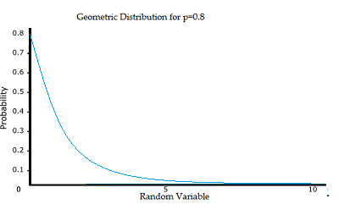](https://www.statisticshowto.datasciencecentral.com/wp-content/uploads/2015/05/geometric-distribution.png)  
  
  
Theoretically, there are an infinite number of geometric distributions. The value of any specific distribution depends on the value of the probability p.

## Assumptions for the Geometric Distribution

The three assumptions are:

* There are two possible outcomes for each trial (success or failure).
* The trials are independent.
* The probability of success is the same for each trial.

# Hypergeometric Distribution: Examples and Formula

[Statistics Definitions](https://www.statisticshowto.datasciencecentral.com/probability-and-statistics/statistics-definitions/) > Hypergeometric Distribution

The **hypergeometric distribution** is a [probability distribution](https://www.statisticshowto.datasciencecentral.com/probability-distribution/) that’s very similar to the [binomial distribution](https://www.statisticshowto.datasciencecentral.com/probability-and-statistics/binomial-theorem/binomial-distribution-formula/). In fact, the binomial distribution is a very good approximation of the hypergeometric distribution as long as you are sampling 5% or less of the [population](https://www.statisticshowto.datasciencecentral.com/what-is-a-population/).  
Therefore, in order to understand the hypergeometric distribution, you should be very familiar with the binomial distribution. Plus, you should be fairly comfortable with the [combinations](https://www.statisticshowto.datasciencecentral.com/probability-and-statistics/probability-main-index/permutation-combination-formula/#comb)formula.  
[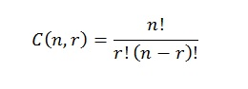](https://www.statisticshowto.datasciencecentral.com/wp-content/uploads/2013/01/combinations.jpg)

The multinomial distribution is used to find probabilities in experiments where there are more than two outcomes.

The **negative binomial** is similar to the binomial with two differences (specifically to numbers 1 and 5 in the list above):

* The number of trials, n **is not fixed**.
* A [random variable](https://www.statisticshowto.datasciencecentral.com/random-variable/) Y= the number of trials needed to make r successes.

main difference from the [binomial distribution](https://www.statisticshowto.datasciencecentral.com/probability-and-statistics/binomial-theorem/binomial-distribution-formula/): with a regular binomial distribution, you’re looking at the number of successes. With a negative binomial distribution, it’s the number of failures that counts.

## The Negative Binomial Formula

**Probability**:  
b*(x; r, P) = x-1Cr-1 * Pr * (1 – P)x – r  
where x=number of trials  
r = Successes

**Mean**:  
μ = r / P  
where r is the number of trials  
P=probability of success for any trial

## What is the Poisson Distribution?

A Poisson distribution is a tool that helps to predict the probability of certain events from happening when you know how often the event has occurred. It gives us the [**probability**](https://www.statisticshowto.datasciencecentral.com/probability-and-statistics/probability-main-index/)**of a given number of events happening in a fixed interval of time**.

[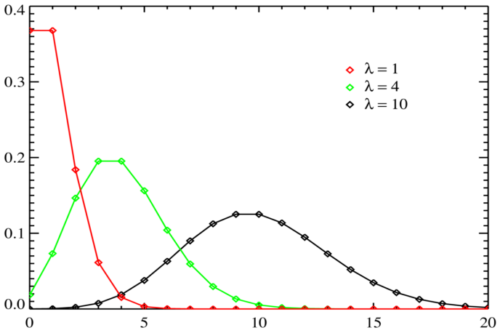](https://www.statisticshowto.datasciencecentral.com/wp-content/uploads/2013/10/poisson-distribution.png)

*Poisson distributions, valid only for*[*integers*](https://www.statisticshowto.datasciencecentral.com/integer/)*on the horizontal axis. λ (also written as μ) is the expected number of event occurrences.*

### Calculating the Poisson Distribution

*The Poisson Distribution [pmf](https://www.statisticshowto.datasciencecentral.com/probability-mass-function-pmf/) is: P(x; μ) = (e-μ * μx) / x!*

Where:

* The symbol “!” is a [factorial](https://www.statisticshowto.datasciencecentral.com/factorial-distribution/#definition).
* μ (the expected number of occurrences) is sometimes written as λ. Sometimes called the **event rate** or [rate parameter](https://www.statisticshowto.datasciencecentral.com/rate-parameter/).